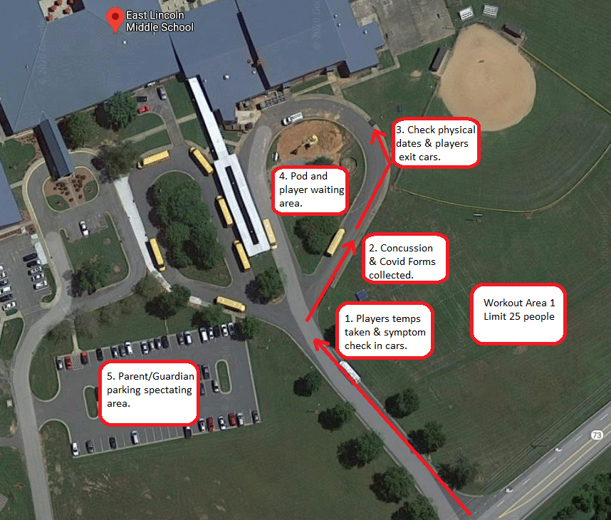
Workouts and registration will be held from 6pm until 7:30pm on July 7th and 9th. Additional dates may be added. Registration will be from 6pm to 6:45pm. Anyone arriving after 6:45pm will not be allowed to participate until the next workout. Athletes will be divided into workout pods of no more than 10 people including coaches. Parents/Guardians/Athletes must stay in their cars in the registration area until athlete’s paperwork is cleared by coaches to join a workout pod. Parents/Guardians who chose to spectate must park in teacher parking area and remain in their cars.
Athletes need a physical clearing them to play football signed and dated by a doctor. Sports physicals will be considered valid as far back as March 1, 2019. Athletes will need a completed NCHSAA Initial Screening for COVID-19 form and an updated Concussion form. Forms can be downloaded online and filled out in advance.
Athletes must bring their own water container with their names clearly on them. We suggest a large container of at least one gallon. Athletes may wear masks when not exercising. Everyone must remain at least 6 feet apart. Athletes should wear cleats or tennis shoes, shorts and a light-colored t-shirt. Remember to drink plenty of water during the days leading up to workouts.

